./

Learning Report – MBSE

Course Code: <CODE>



|  |  |  |  |  |  |
| --- | --- | --- | --- | --- | --- |
| **Ver. Rel. No.** | **Release Date** | **Prepared. By** | **Reviewed By** | **Approved By** | **Remarks/Revision Details** |
| 1 | 21/09/20 | Milind Mohapatra |  |  |  |
| 2 | 23/09/20 | Milind Mohapatra |  |  |  |
| 3 | 25/09/20 | Milind Mohapatra |  |  |  |
|  |  |  |  |  |  |
|  |  |  |  |  |  |

**Document History**

# 

Table of Contents

Table of Figures 5

Revolutionizing MBSE by Gulfstream Aerospace 6

Origin 6

Challenges faced up till 2003 7

What happened after 2003 7

Tools and software used by Gulfstream Aerospace 7

Equation Modelling 9

Logical Expression: 9

Trigonometric Expression: 10

Water level: 10

First Order Differential Expression: 11

Second Order Differential Expression: 11

Activity 4: MATLAB programming 12

Import data 12

Import the data 12

Create output variable 12

Create table 12

Allocate imported array to column variable names 12

Clear temporary variables 12

Assign independent variables for all the sensors 12

Time Normalization 13

Linear acceleration data analysis 13

Clear no longer required variables 14

Gravity sensor data analysis 14

Sensor Fusion 15

Clear no longer required variables 16

Accessing ride quality 16

Putting together all data 17

Write all the data to a csv file named "ALL_DATA_LOGS" 17

Activity 8– Debugging methods in Simulink 18

Activity 9– Different Types of Subsystem 31

Atomic Subsystem: 31

Non Atomic subsystem: 32

Triggered Subsystem: 32

Enabled subsystem: 35

Variant subsystem: 38

Appendix 41

MATLAB OnRamp course certificate 41

Simulink Onramp course certificate 42

# Table of Figures

Figure 1 Gulfstream G650 (Image courtesy of Gulfstream) 5

Figure 2 A Gulfstream jet forward fuselage system (Image courtesy of Gulfstream) 6

Figure 3 A fastener projected onto the curved surface of a door (Image courtesy of Gulfstream) 7

Figure 4 Logical expression block diagram 8

Figure 5 Trigonometric expression block diagram 9

Figure 6 Water level block diagram 9

Figure 7 First order differential expression block diagram 10

Figure 8 Second order differential equation block diagram 10

Figure 9 Rate of change of acceleration 13

Figure 10 Rate of change of perceived gravity 14

Figure 11 Bumps on the road 15

Figure 12 Simulink model for Temperature conversion (C to F) 17

Figure 13 Passing simulation using Pause time 18

Figure 14 Scope values 18

Figure 15 Label display on signal line 19

Figure 16 Label values during simulation 20

Figure 17 Breakpoint addition in signal line 21

Figure 18 Breakpoint Execution 22

Figure 19 The execution is paused at breakpoint 23

Figure 20 Execution order of the system 24

Figure 21 Colored Legend representation 25

Figure 22 Logging creation at signal line 26

Figure 23 Log compare of two signals 27

Figure 24 Highlighting source and destination 28

Figure 25 Floating Viewer Test Model 29

Figure 26 Floating Viewer /Scope in Signal Lines 29

Figure 27 Subsystem 30

Figure 28 Triggered Subsystem 32

Figure 29 Enabled Subsystem 35

Figure 30 Matlab Onramp certificate 40

Figure 31 Simulink onramp certificate 41

Figure 32 Stateflow onramp certificate 42

# Revolutionizing MBSE by Gulfstream Aerospace

## **Origin**

Gulfstream aerospace company is an American company and a wholly owned subsidiary of General Dynamics. They design, develop, manufacture, market and service business jet aircrafts such as the Gulfstream G650 model shown in figure 1. Gulfstream has produced more than 2000 aircrafts since 1958.

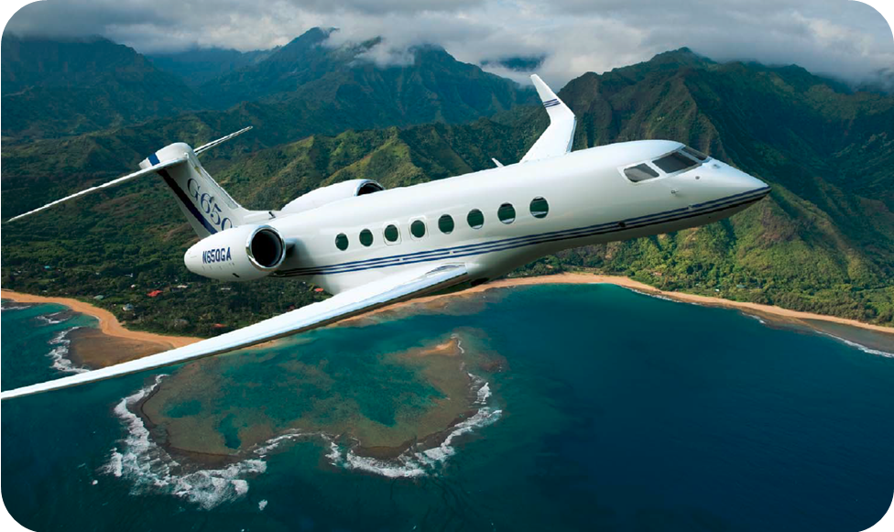

Figure 1 Gulfstream G650 (Image courtesy of Gulfstream)

## **Challenges faced up till 2003**

* Historically been low volume, highly custom, hand built interiors
* Relied on highly skilled craftsmen to interpret engineering drawings with limited content
* Model based design process was needed to support higher volume production

## **What happened after 2003**

In 2003, Gulfstream Aerospace implemented MBD (Model Based Design) and have since achieved a series of remarkable successes. Developing and FAA-certifying the industry’s first and currently only electronic 3D MBTD System and the G650 aircraft being the first completely 3D MBTD system designed and certified are a few of those successes.

Between the 2D drawing approach for the G550 model and the MBD approach for the G650 model, the standard parts and part numbers were reduced by more than 50 percent. Even more amazingly, the number of outfitting clips, angles and brackets were reduced from around 450 down to only 6. The reduction of part numbers alone generated huge savings in the supply chain management.

## **Tools and software used by Gulfstream Aerospace**

1. **CATIA V5**: To provide a true 3D electronic representation of the aircraft, the engineering team modeled everything, including fasteners, veneer, hoses and so on, as the nominal geometries using CATIA V5. The 3D digital models allowed the team to increase the part reuse during the design phase, minimize technician’s subjective customization on the shop floor and ultimately reduce part numbers by more than 50 percent. Nowadays, the model-based interior design has been expanded to the entire airplane fleet.

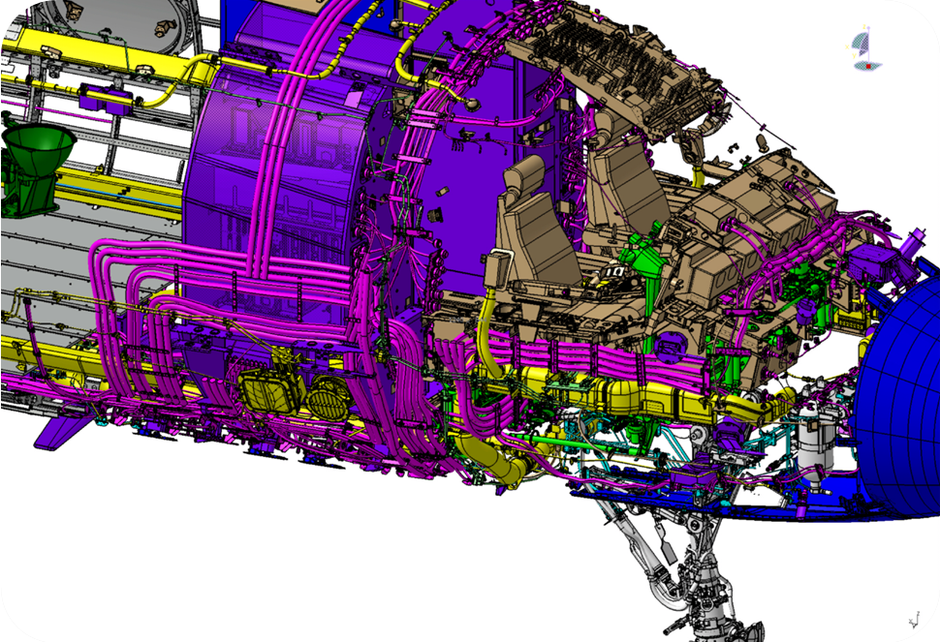

Figure 2 A Gulfstream jet forward fuselage system (Image courtesy of Gulfstream)

1. **ProjectWorks:** Using this software, along with multiple high-resolution laser projectors, Gulfstream projects the fastener map directly onto the airplane’s body. The projectors coordinate with each other to bend and reshape the image to make sure that all the fasteners are correctly located on the curved surface. With the digital model projection, you can modify the model or instructions in real time and they will be instantly updated and mapped correctly onto the airplane, without having to wait for the redrawn physical nylon pieces anymore. One tip here is that rather than using actual protrusions, Gulfstream only models the fasteners as points and vectors with attributes such as types, tooling and pre-drill information. This can prevent the model heaviness from being loaded onto computers.

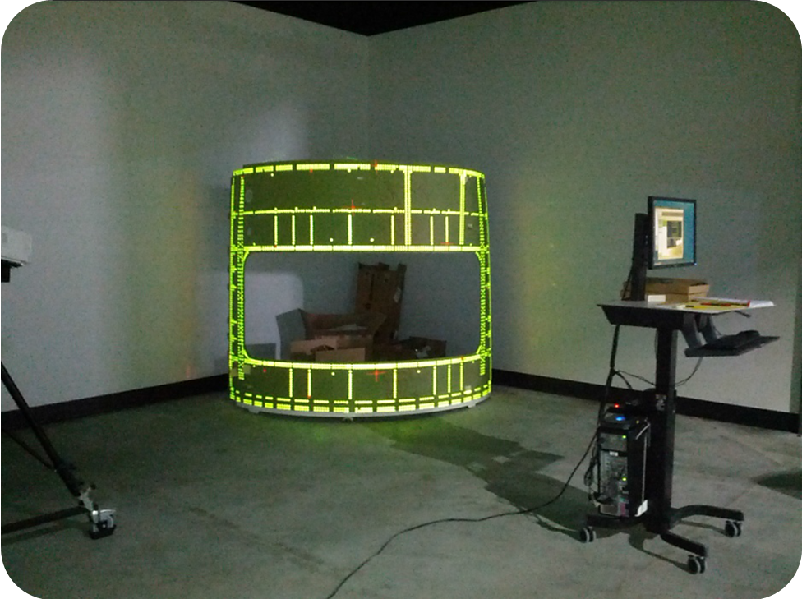

Figure 3 A fastener projected onto the curved surface of a door (Image courtesy of Gulfstream)

1. **Gulfstream SymmetryTM Flight Deck: A** fully featured model based systems engineering tools and program support simulator.
2. **Matlab and Simulink:** Simulink, Aerospace Blockset, and Simulink Coder to model and simulate the digital flight-control system and aircraft dynamics in real time.
3. **MSC Nastran**
4. **Patran**
5. **Apex**
6. **HyperWorks suite**
7. **Abaqus**
8. **SmarTeam**

# Equation Modelling

## Logical Expression:

((a<b) && !(b>c)) || ((a==c) && !(b==2))

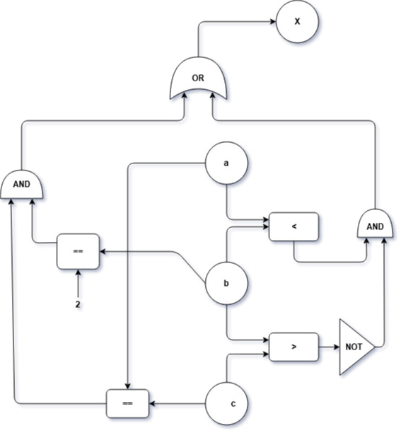

Figure 4 Logical expression block diagram

## Trigonometric Expression:

v = 1/3(pi*r2*h)

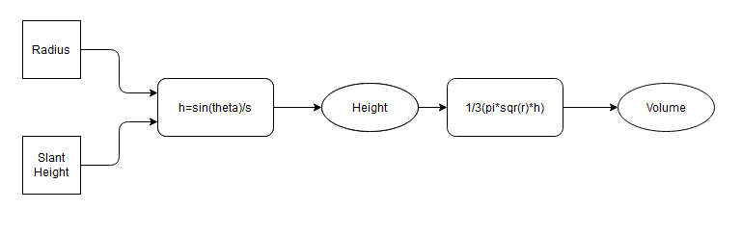

Figure 5 Trigonometric expression block diagram

## Water level:

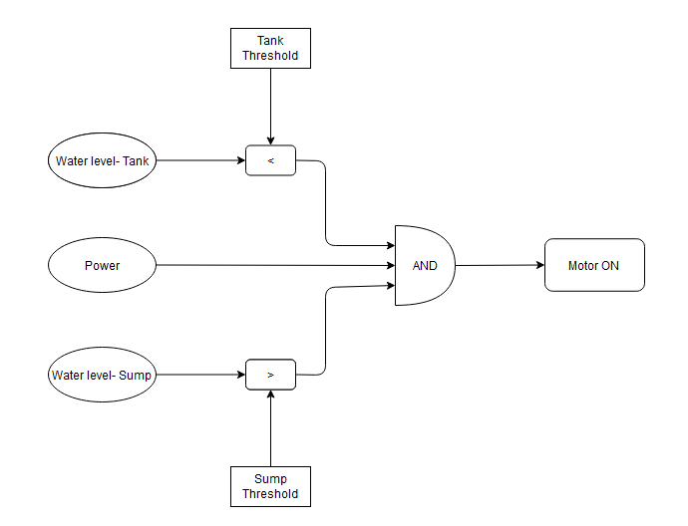

Figure 6 Water level block diagram

## First Order Differential Expression:

y’ + a(x)y = y(x)

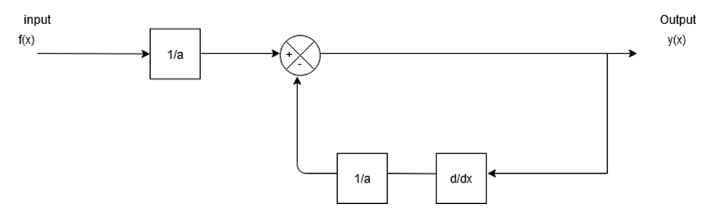

Figure 7 First order differential expression block diagram

## Second Order Differential Expression:

y(t) = $-\left(\frac{B}{M}\right)y^{'}\left(t\right)-\left(\frac{k}{M}\right)y\left(t\right)+\left(\frac{1}{M}\right)f\left(t\right)$

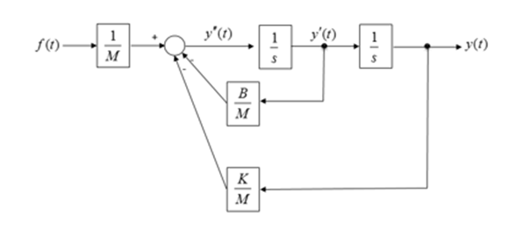

Figure 8 Second order differential equation block diagram

# Activity 4: MATLAB programming

## Import data

Script for importing data from the following spreadsheet:

Worksheet: D:\Matlab\Genesis-Matlab\database\log.csv

@author : Milind Mohapatra  
 @PS no. : 99002670

## Import the data

[acc] = xlsread('D:\MATLAB\Genesis-Matlab\database\log.csv','G2:I4457');  
[gravity] = xlsread('D:\MATLAB\Genesis-Matlab\database\log.csv','D2:F4457');  
[time] = xlsread('D:\MATLAB\Genesis-Matlab\database\log.csv','AD2:AD4457');  
raw = [acc,gravity,time];

## Create output variable

data = raw;

## Create table

bus_data = table;

## Allocate imported array to column variable names

bus_data.ACCNx = data(:,1);  
bus_data.ACCNy = data(:,2);  
bus_data.ACCNz = data(:,3);  
bus_data.GRAVITYx = data(:,4);  
bus_data.GRAVITYy = data(:,5);  
bus_data.GRAVITYz = data(:,6);  
bus_data.TIME = data(:,7);

## Clear temporary variables

clearvars raw acc gravity time;

## Assign independent variables for all the sensors

%Linear Acceleration on all three axes  
ax = bus_data.ACCNx;  
ay = bus_data.ACCNy;  
az = bus_data.ACCNz;  
%Gravity changes on all three axes  
gx = bus_data.GRAVITYx;  
gy = bus_data.GRAVITYy;  
gz = bus_data.GRAVITYz;  
%Time  
t_temp = bus_data.TIME;  
iteration = 4455;

## Time Normalization

for i = 1:iteration  
 t(i,:) = t_temp(i+1,1) - t_temp(i,1);  
end  
  
t_real(1,1) = 0;  
for i = 1:iteration  
 t_real(i+1,:) = t_real(i,:) + t(i,:);  
end  
%Time elapsed in seconds  
t_real = t_real.*0.001;  
  
%Clear no longer required variables  
clearvars t_temp;  
clearvars t;

## Linear acceleration data analysis

%Change in acceleration every 0.1s on each axis  
for i = 1:iteration  
 axt(i,:) = ax(i+1,1)-ax(i,1);  
end  
  
for i = 1:iteration  
 ayt(i,:) = ay(i+1,1)-ay(i,1);  
end  
  
for i = 1:iteration  
 azt(i,:) = az(i+1,1)-az(i,1);  
end  
  
%Combining the acceleration change over all axis  
acc_temp = sum(axt.^2 + ayt.^2 + azt.^2, 2);  
acc_change = sqrt(acc_temp);  
  
%Plot overall acceleration changes throughout journey  
subplot(3,1,1);  
plot(acc_change, 'm');  
xlabel('Time in secs');  
ylabel('Accleration in m/s^2');  
title('RATE OF CHANGE OF ACCELERATION');

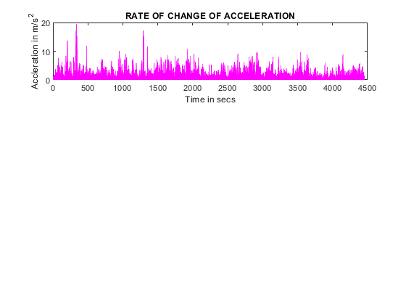

Figure 9 Rate of change of acceleration

## Clear no longer required variables

clearvars acc_temp ax ay az;  
clearvars axt ayt azt;

## Gravity sensor data analysis

for i = 1:iteration  
 gxt(i,:) = gx(i+1,1)-gx(i,1);  
end  
  
for i = 1:iteration  
 gyt(i,:) = gy(i+1,1)-gy(i,1);  
end  
  
for i = 1:iteration  
 gzt(i,:) = gz(i+1,1)-gz(i,1);  
end  
  
gvt_change = sum(gxt.^2 + gyt.^2 + gzt.^2, 2);  
  
%Plot overall gravity changes throughout journey  
subplot(3,1,2);  
plot(gvt_change);  
xlabel('Time');  
ylabel('Gravity in m/s^2');  
title('RATE OF CHANGE OF PERCIEVED GRAVITY');

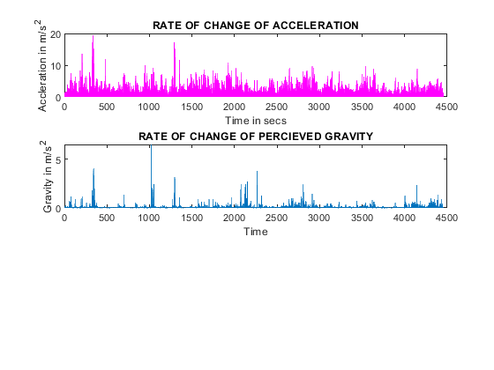

Figure 10 Rate of change of perceived gravity

## Sensor Fusion

%Use of custom function : fuse(arg1,arg2S)  
final_data = fuse(acc_change, gvt_change);  
subplot(3,1,3);  
plot(final_data);  
xlabel('Time');  
ylabel('Bumps');  
title('BUMPS ON THE ROAD');

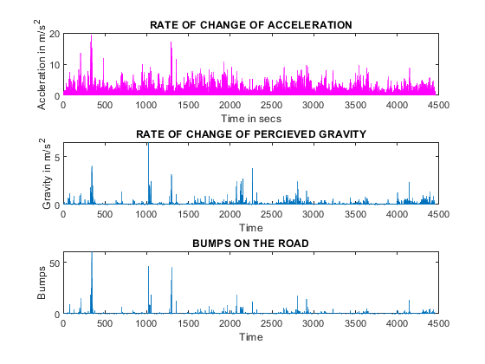

Figure 11 Bumps on the road

## Clear no longer required variables

clearvars gx gy gx;  
clearvars gxt gyt gzt;

## Accessing ride quality

bump = 0;  
smooth = 0;  
threshold = 2;  
for i = 1: iteration  
 if final_data(i,:) > threshold  
 bump = bump + 1;  
 else  
 smooth = smooth + 1;  
 end  
end  
  
total_counter = bump+smooth;  
percent_good_ride = (smooth/total_counter)*100;  
percent_bad_ride = (bump/total_counter)*100;  
percent_bad_ride = round(percent_bad_ride);  
DISPLAY = sprintf('%d percent of the total ride was bad', percent_bad_ride);  
disp(DISPLAY);

3 percent of the total ride was bad

## Putting together all data

for i = i:size(final_data)  
 null_matrix(i,:) = 0000;  
end  
alldata = horzcat(data(2:end,1),data(2:end,2),data(2:end,3),data(2:end,4),data(2:end,5),data(2:end,6),data(2:end,7),null_matrix, acc_change,gvt_change,final_data);

## Write all the data to a csv file named "ALL_DATA_LOGS"

csvwrite('ALL_DATA_LOGS.csv', alldata);

[Published with MATLAB® R2020b](https://www.mathworks.com/products/matlab)

# Activity 8– Debugging methods in Simulink

**Model:** Temperature conversion from Celsius to Fahrenheit

**Simulink Model:**

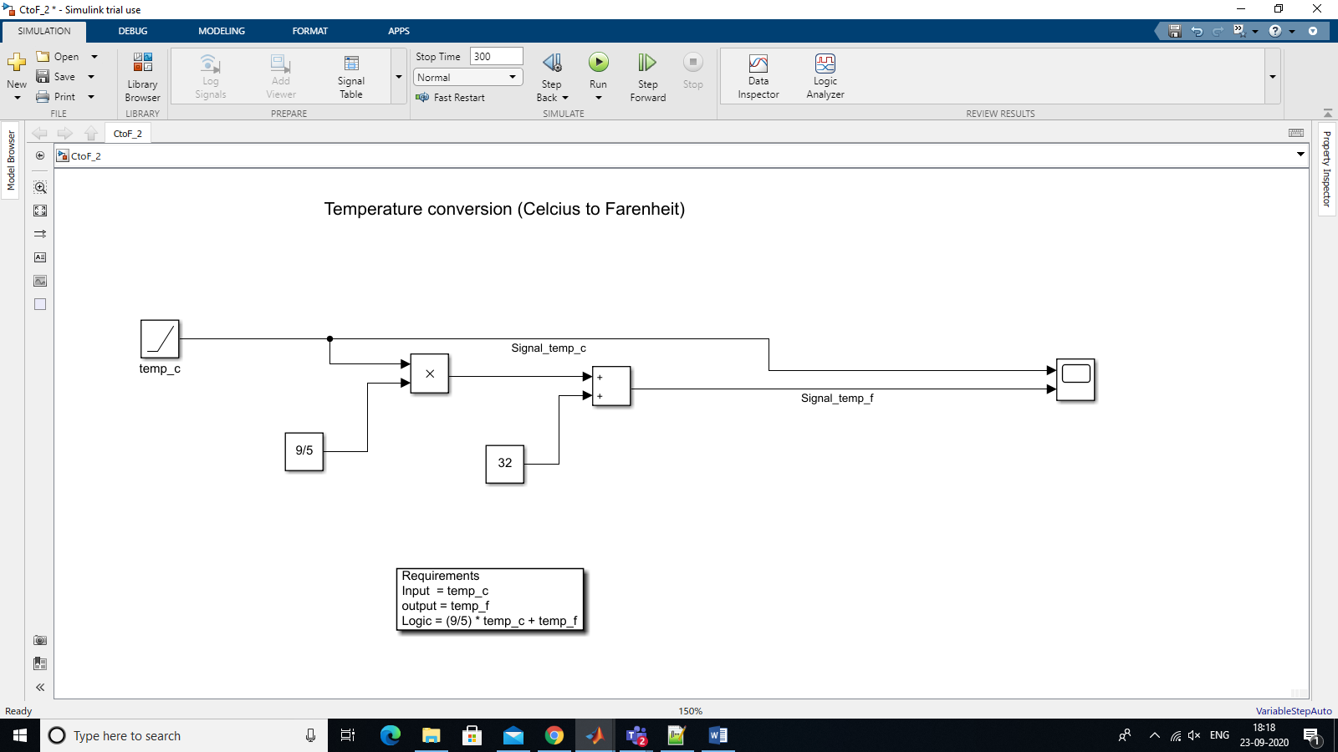

Figure 12 Simulink model for Temperature conversion (C to F)

Rquirements:

Input: Temperature in Celsius

Output: Temperature in Fahrenheit

temp_f = (9/5) * temp_c + 32

1. **Passing Simulation:**

The simulation can be passed by setting desired time to ‘Pause time’ in DEBUG tab.

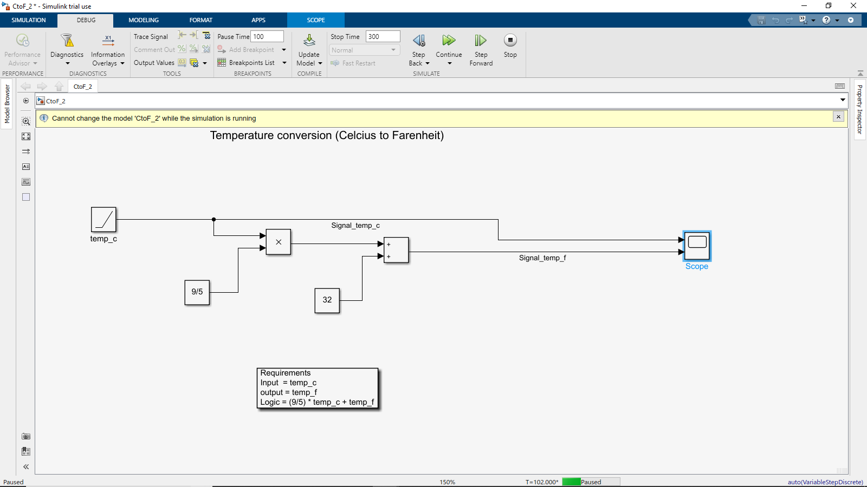

Figure 13 Passing simulation using Pause time

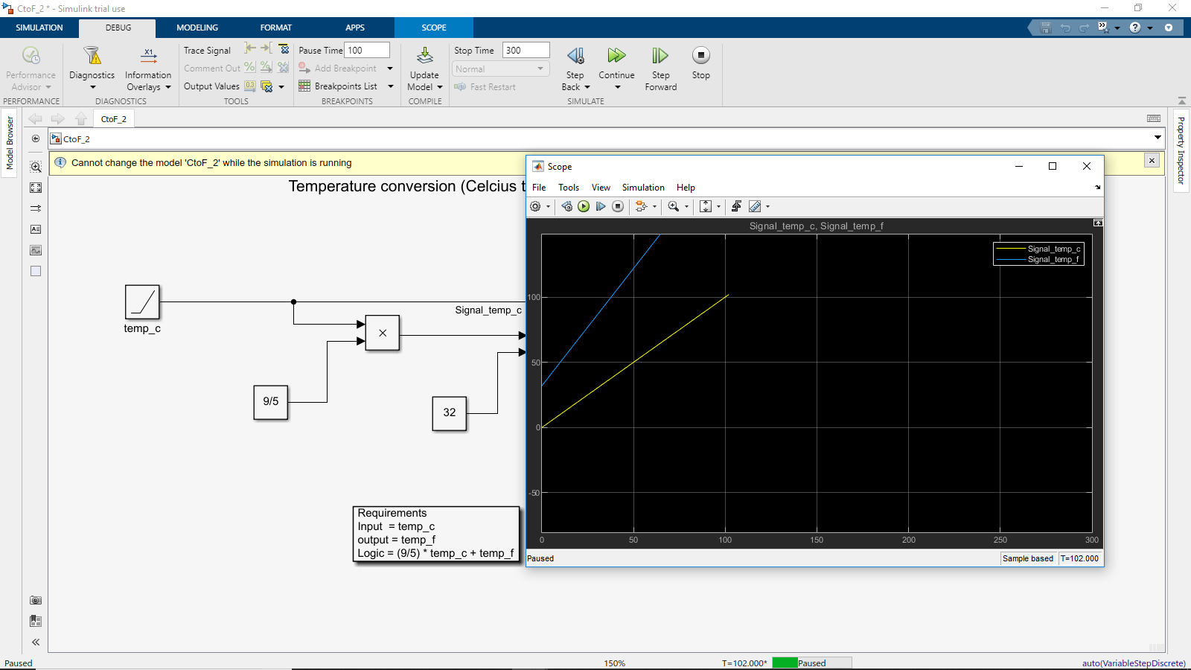

Figure 14 Scope values

1. **Show label**

Right click on signal line to add Label name.

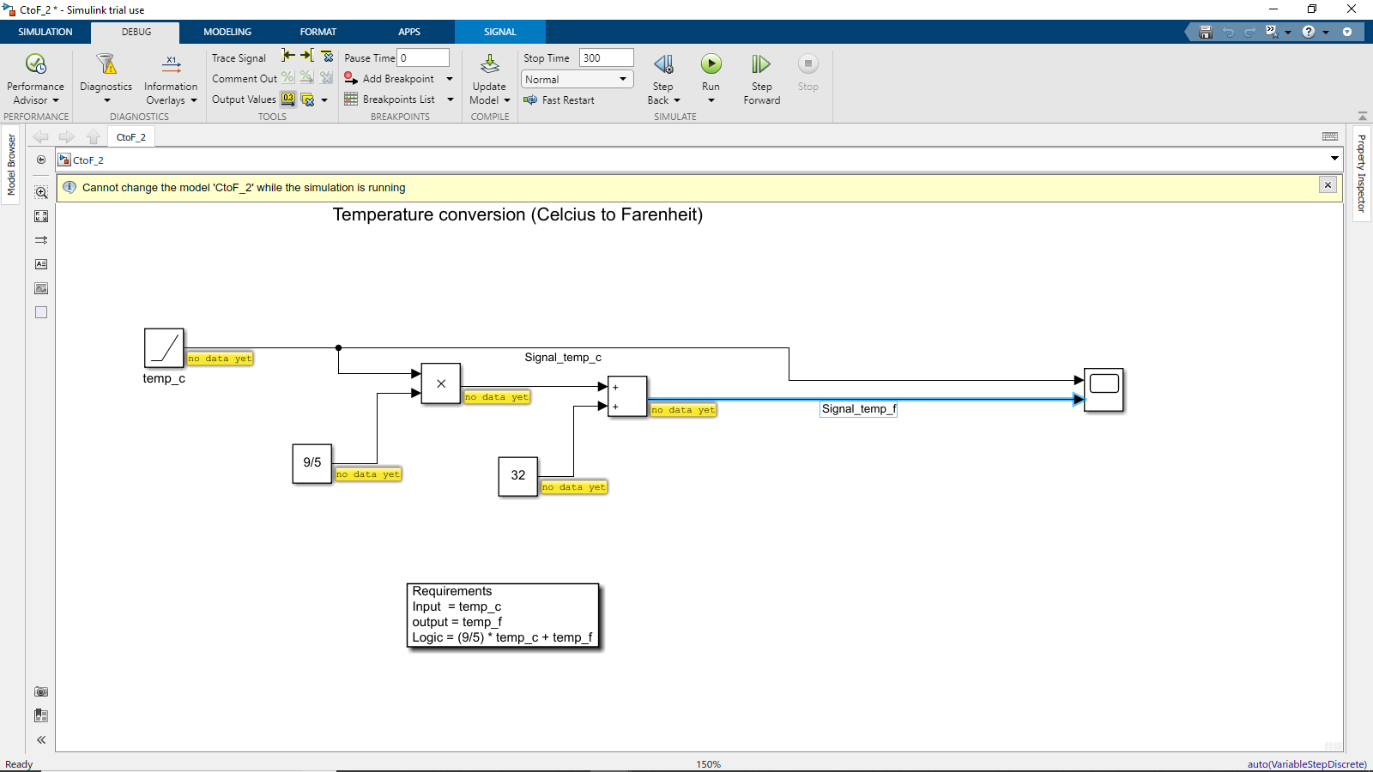

Figure 15 Label display on signal line

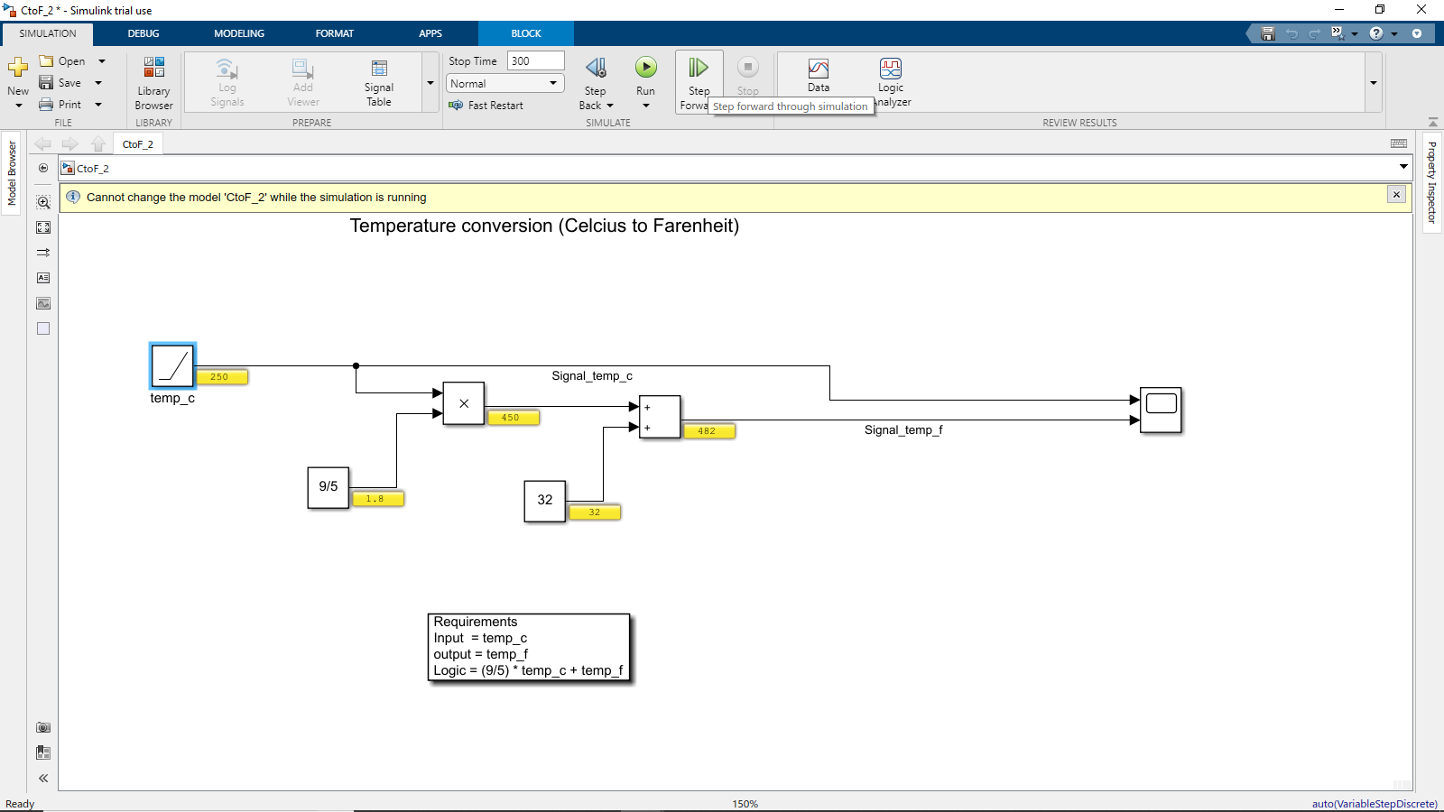

Figure 16 Label values during simulation

1. **Adding breakpoint:**

Breakpoints can be added to the signal lines to pause the execution.

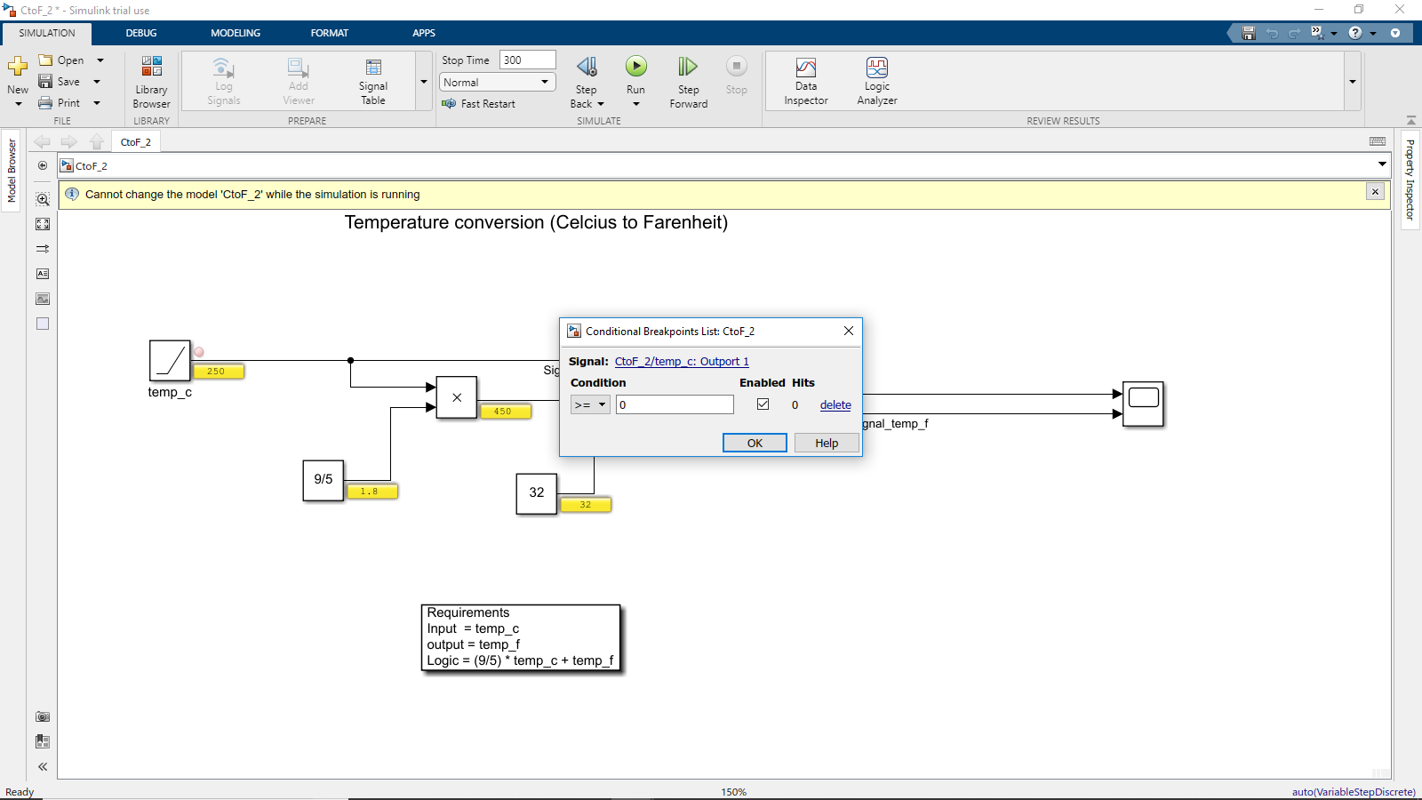

Figure 17 Breakpoint addition in signal line

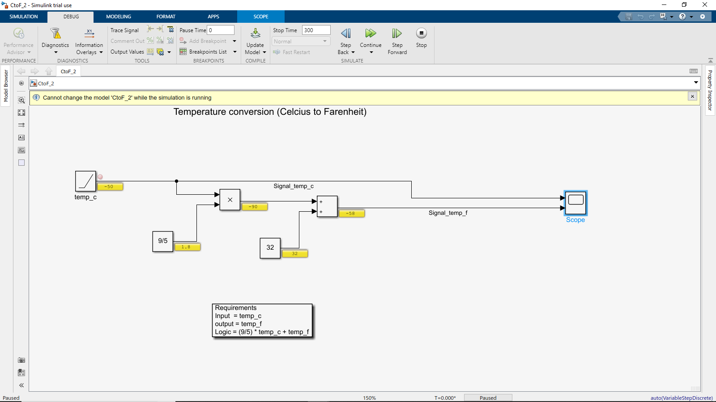

Figure 18 Breakpoint Execution

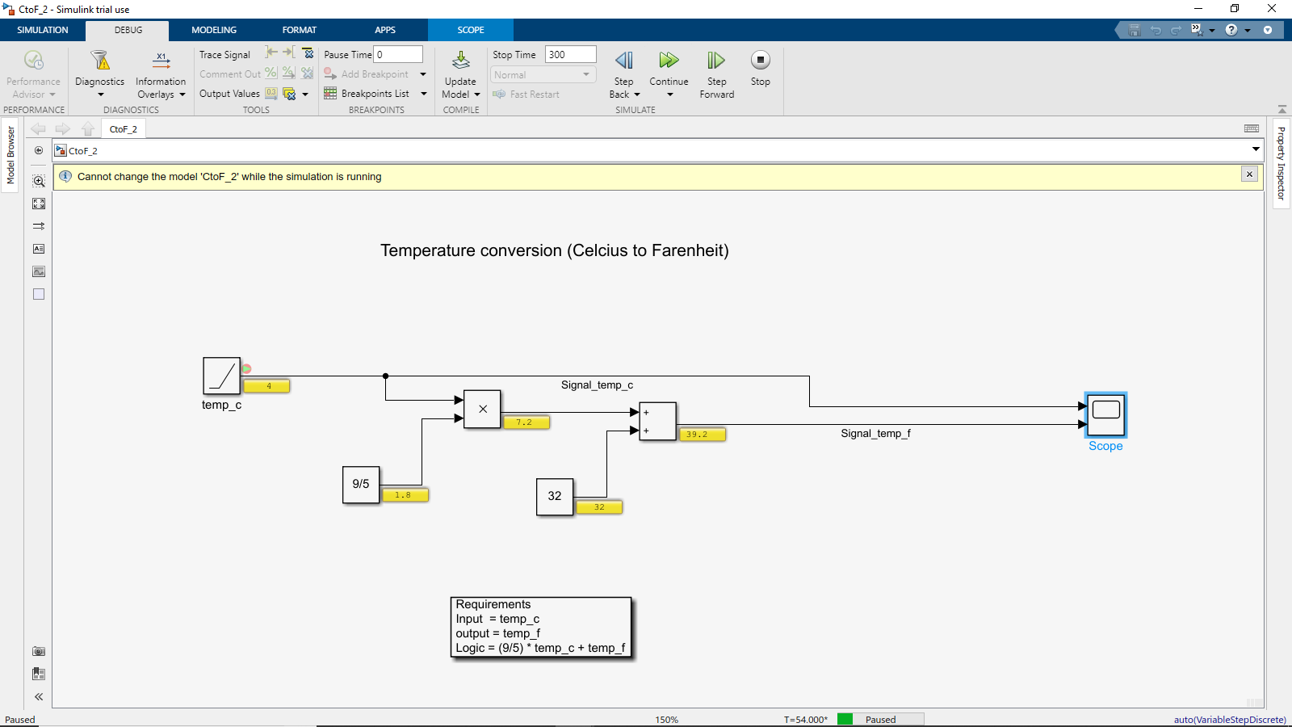

Figure 19 The execution is paused at breakpoint

1. **Understanding Execution Order**

Click on Information Overlays, to enable execution order for the system

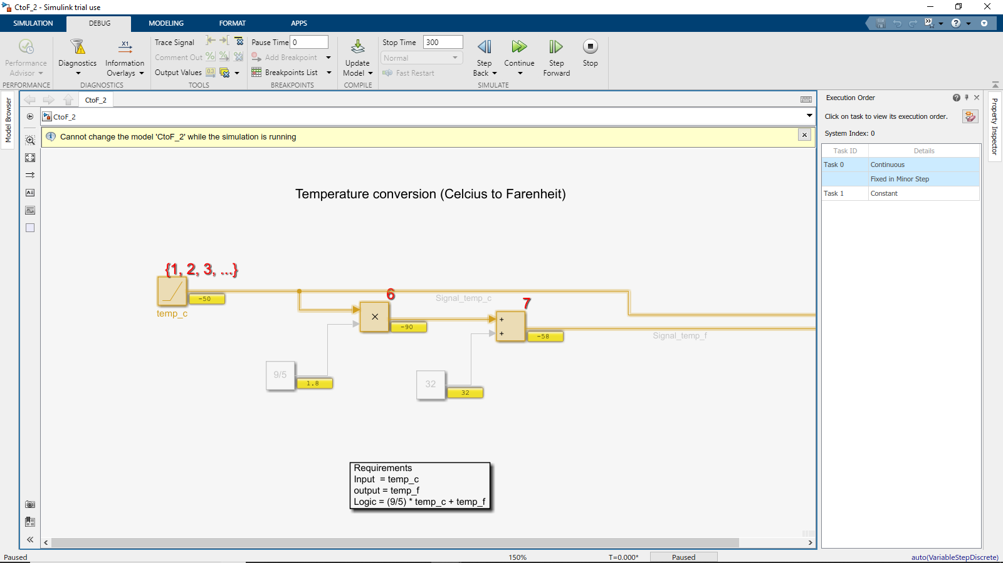

Figure 20 Execution order of the system

1. **Sampling Time (Timing Legend)**

Click on Information Overlays, to enable Legends and Colors. It differentiates constants, continuous and fixed input with different colors.

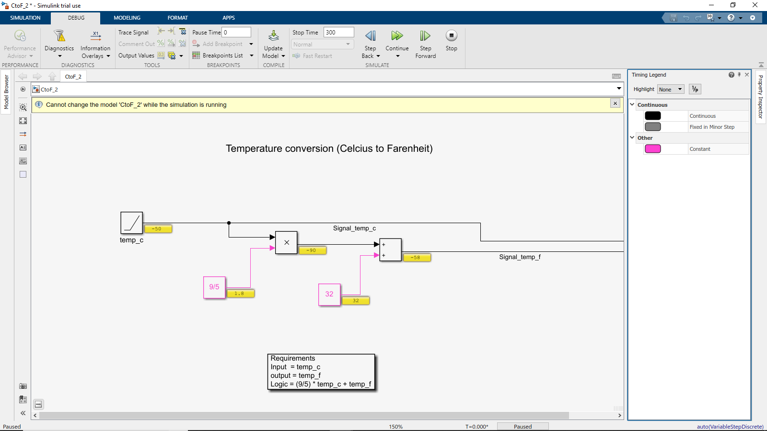

Figure 21 Colored Legend representation

1. **Logging**

Signal logging enables logging data for specified signals to the MATLAB workspace and the Simulation Data Inspector. 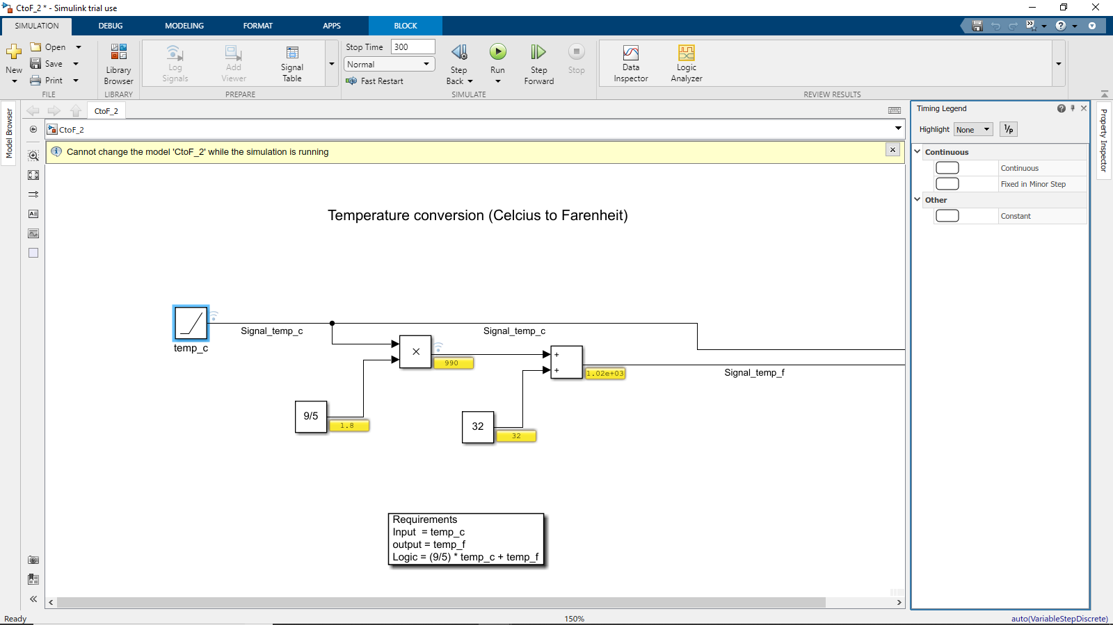

Figure 22 Logging creation at signal line

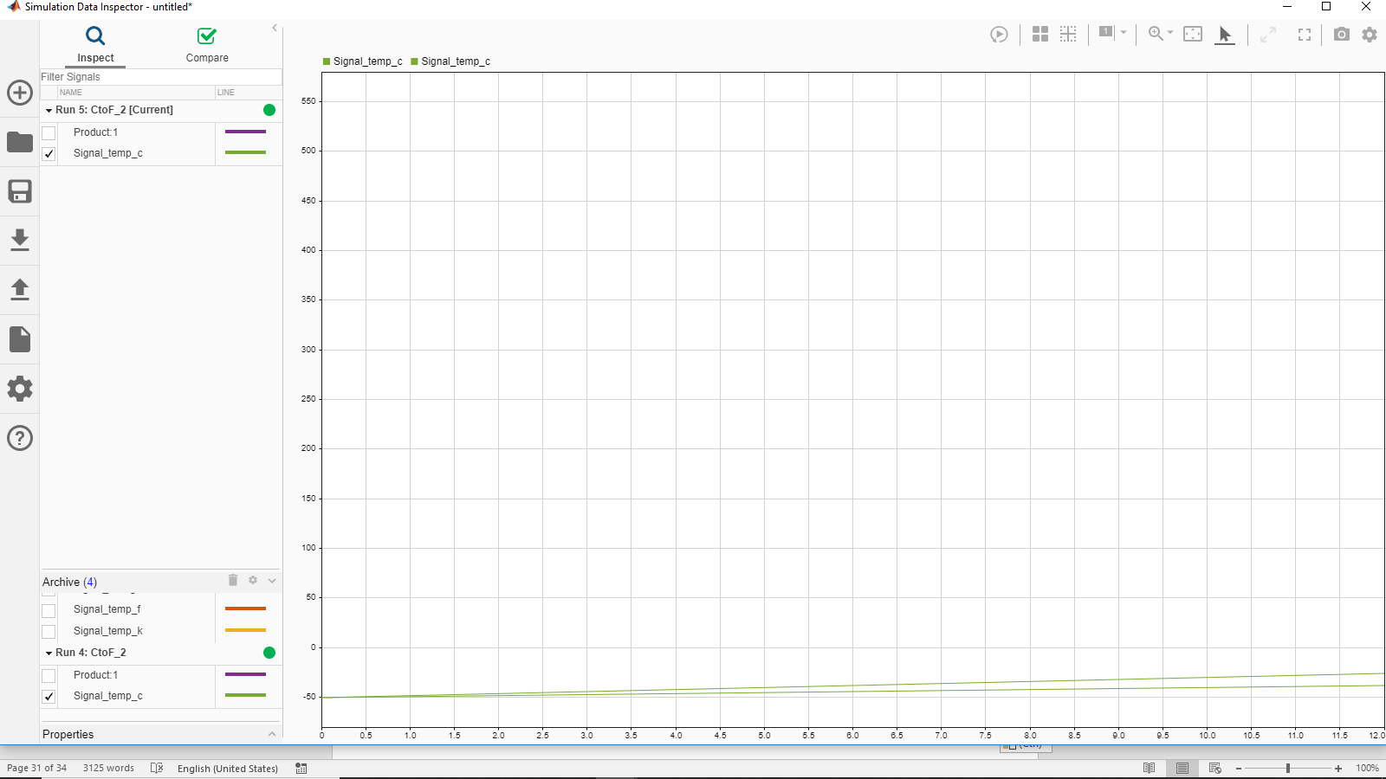

Figure 23 Log compare of two signals

1. **Highlight to Source and Destination**

Right click on any signal line to highlight the Source and Destination path.

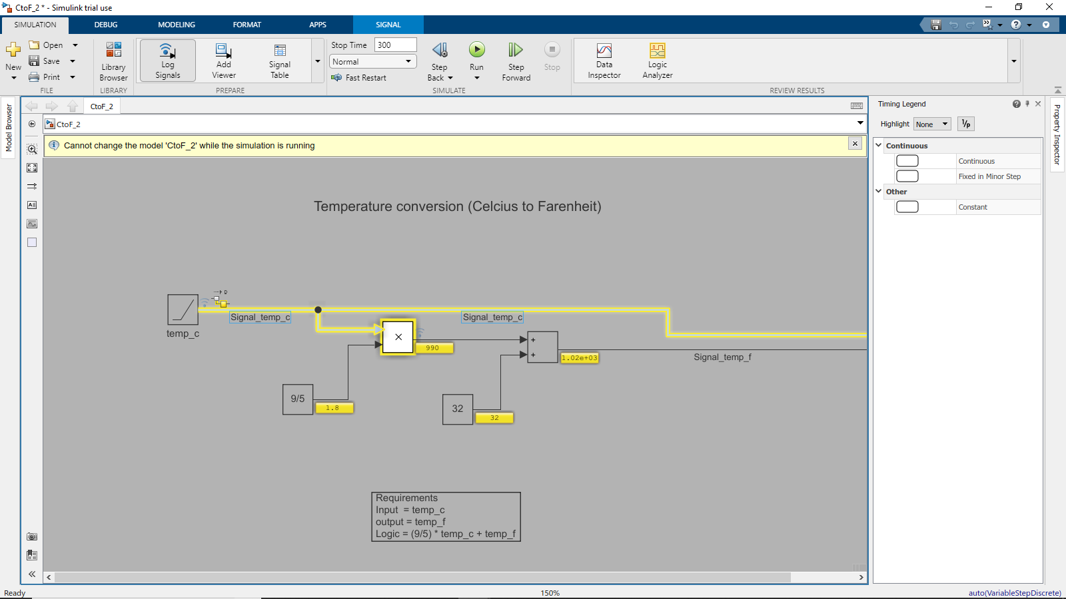

Figure 24 Highlighting source and destination

1. **Floating Viewer/ Scope**

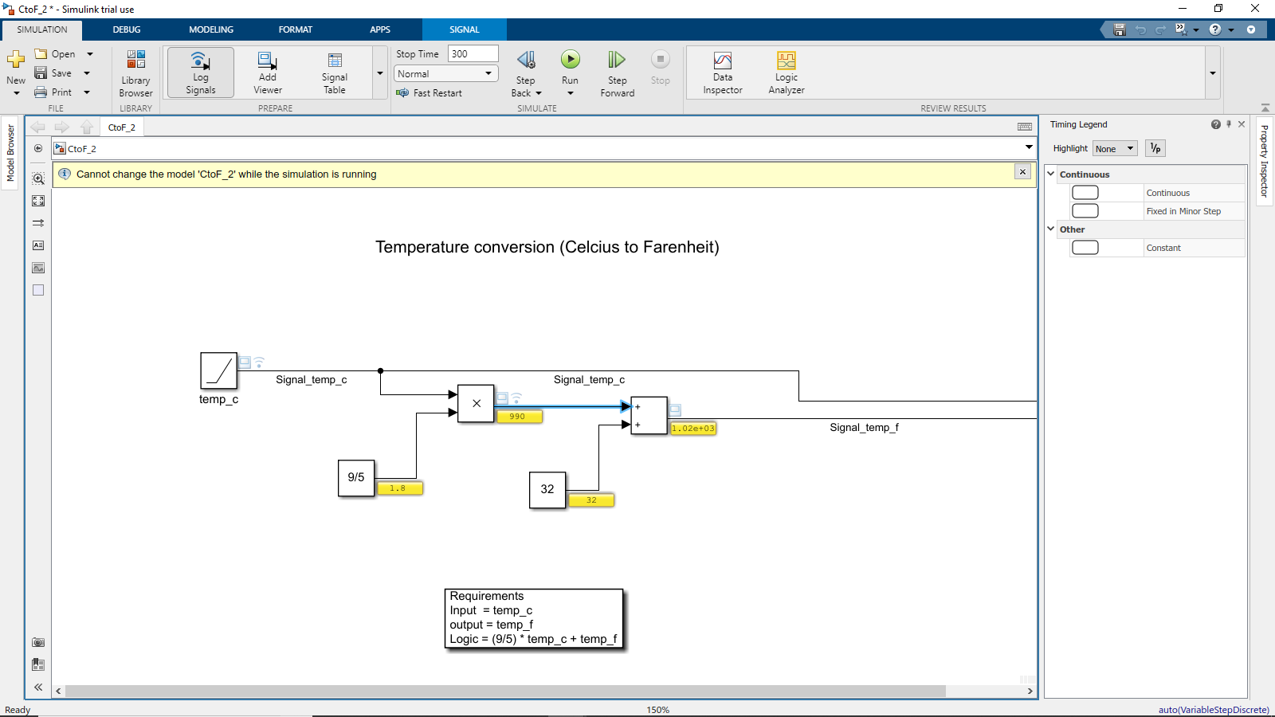

Figure 25 Floating Viewer Test Model

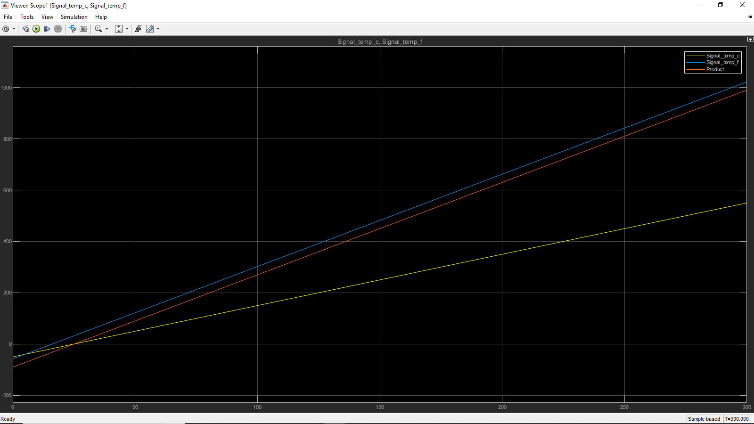

Figure 26 Floating Viewer /Scope in Signal Lines

# Activity 9– Different Types of Subsystem

## Atomic Subsystem:

Atomic Subsystem block is a Subsystem block that has its Treat as Atomic Unit parameter selected by default. A Subsystem can be created in these ways:

* Copy the Subsystem (or Atomic Subsystem) block from the Ports & Subsystems library into your model. You can then add blocks to the subsystem by opening the Subsystem block and copying blocks into its window.
* Select the blocks and lines that are to make up the subsystem using a bounding box, then choose Create Subsystem from the Edit menu. Simulink replaces the blocks with a Subsystem block. When you open the block, the window displays the blocks you selected, adding Inport and Outport blocks to reflect signals entering and leaving the subsystem.

The number of input ports drawn on the Subsystem block's icon corresponds to the number of Inport blocks in the subsystem. Similarly, the number of output ports drawn on the block corresponds to the number of Outport blocks in the subsystem.

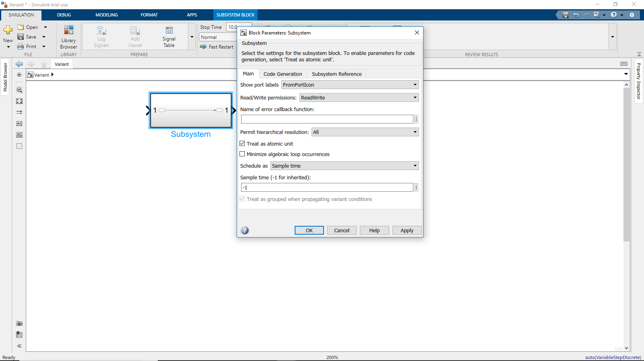

Figure 27 Subsystem

**Treat as atomic unit**

* Causes Simulink to treat the subsystem as a unit when determining block execution order. When it comes time to execute the subsystem, Simulink executes all blocks within the subsystem before executing any other block at the same level as the subsystem block. If this option is not selected, Simulink treats all blocks in the subsystem as being at the same level in the model hierarchy as the subsystem when determining block execution order. This can cause execution of blocks within the subsystem to be interleaved with execution of blocks outside the subsystem. See Atomic Versus Virtual Subsystems for more information.

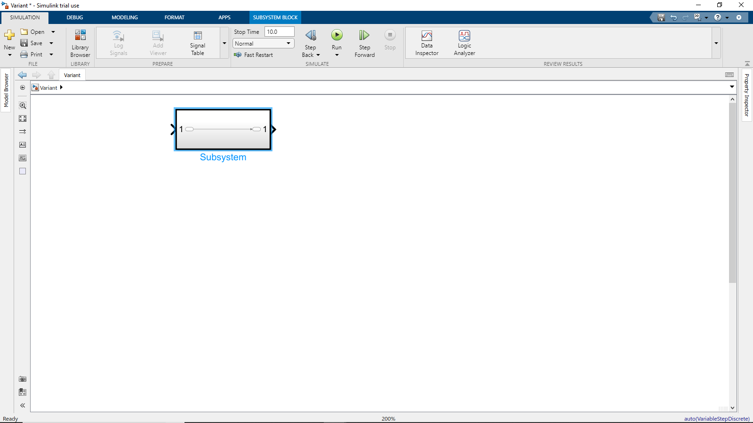

## Non Atomic subsystem:

Non-virtual subsystem Control when the contents of the subsystem are evaluated as a single unit (atomic execution). It creates a conditionally executed subsystems that run only when an event occurs on a triggering, function-call, action, or enabling input.

## Triggered Subsystem:

A triggered subsystem is a conditionally executed atomic subsystem that runs each time the control signal (trigger signal):

* Either rises from a negative value to a positive value or zero, or rises from a zero value to a positive value.
* Either falls from a positive value to a negative value or zero, or falls from a zero value to a negative value.
* Rises or falls through or to a zero value.

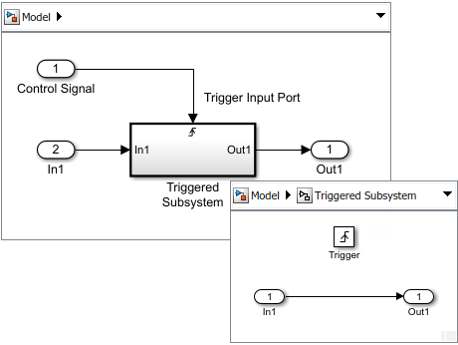

Figure 28 Triggered Subsystem

**Creating a Triggered Subsystem**

To create a triggered subsystem:

* Add a Triggered Subsystem block to your model.
* Copy a block from the Simulink Ports & Subsystems library to your model.
* Click the model diagram, start typing trigger, and then select Triggered Subsystem.

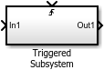

* Set initial and disabled values for the Outport blocks.
* Set how the control signal triggers execution.
* Open the subsystem block, and then open the parameter dialog box for the Trigger port block. From the Trigger type drop-down list, select:
* rising — Trigger execution of the subsystem when the control signal rises from a negative or zero value to a positive value.
* falling — Trigger execution of the subsystem when the control signal falls from a positive or zero value to a negative value.
* either — Trigger execution of the subsystem with either a rising or falling control signal.

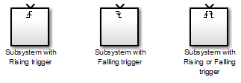

* Output the enable control signal from the Trigger port block. Open the Trigger port block. Select the Show output port check box to pass the control signal into the triggered subsystem.
* From the Output data type drop-down list, select auto, int8, or double. The auto option causes the data type of the output signal to be the data type (either int8 or double) of the block port connected to the signal.

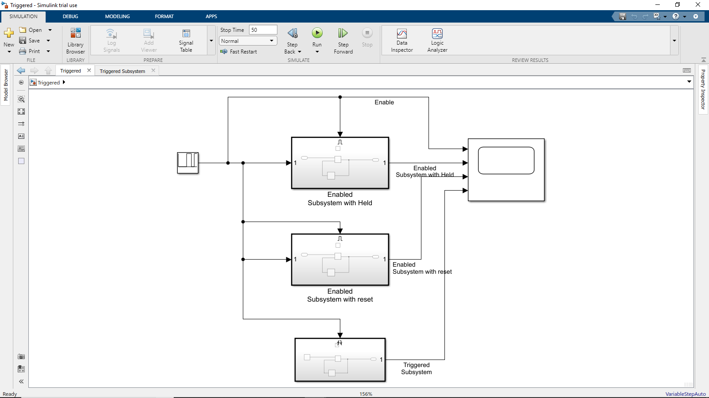

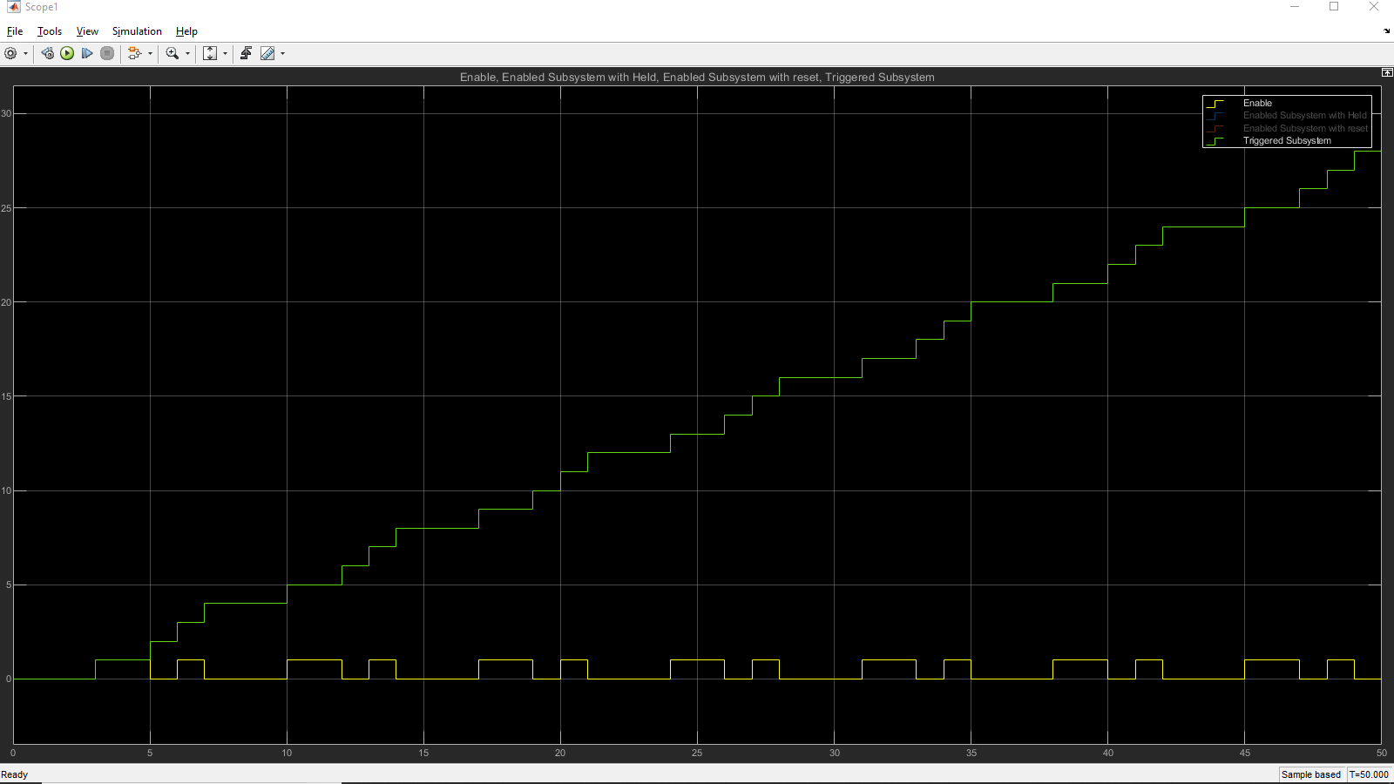

## Enabled subsystem:

**Using Enabled Subsystems:** An enabled subsystem is a conditionally executed subsystem that runs once at each major time step while the control signal enabled subsystem has a positive value. If the signal crosses zero during a minor time step, the subsystem is not enabled or disabled until the next major time step.

The control signal can be either a scalar or a vector.

* If a scalar value is greater than zero, the subsystem executes.
* If any one of the vector element values is greater than zero, the subsystem executes.

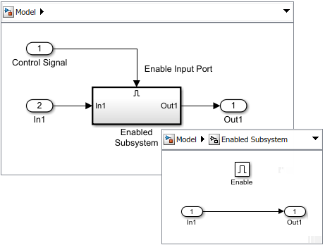

Figure 29 Enabled Subsystem

**Create an Enabled Subsystem**

To create an enabled subsystem:

* Add an Enabled Subsystem block to your model.
  + Copy a block from the Simulink® Ports & Subsystems library to your model.
  + Click the model diagram, start typing enabled, and then select Enabled Subsystem.

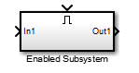

* Set initial and disabled values for the Outport blocks. See [Conditional Subsystem Initial Output Values](https://www.mathworks.com/help/simulink/ug/specify-or-inherit-conditional-subsystem-initial-values.html) and [Conditional Subsystem Output Values When Disabled](https://www.mathworks.com/help/simulink/ug/set-output-values-when-conditional-subsystem-is-disabled.html).
* Specify how subsystem states are handled when the subsystem is enabled. Open the subsystem block, and then open the parameter dialog box for the Enable port block. From the States when enabling drop-down list, select:
  + held — States maintain their most recent values.
  + reset — If the subsystem is disabled for at least one time step, states revert to their initial conditions.
* Output the control signal from the Enable block. In the parameter dialog box for the Enable Block, select the Show output port check box. Selecting this parameter allows you to pass the control signal into the enabled subsystem. You can use this signal with an algorithm that depends on the value of the control signal.

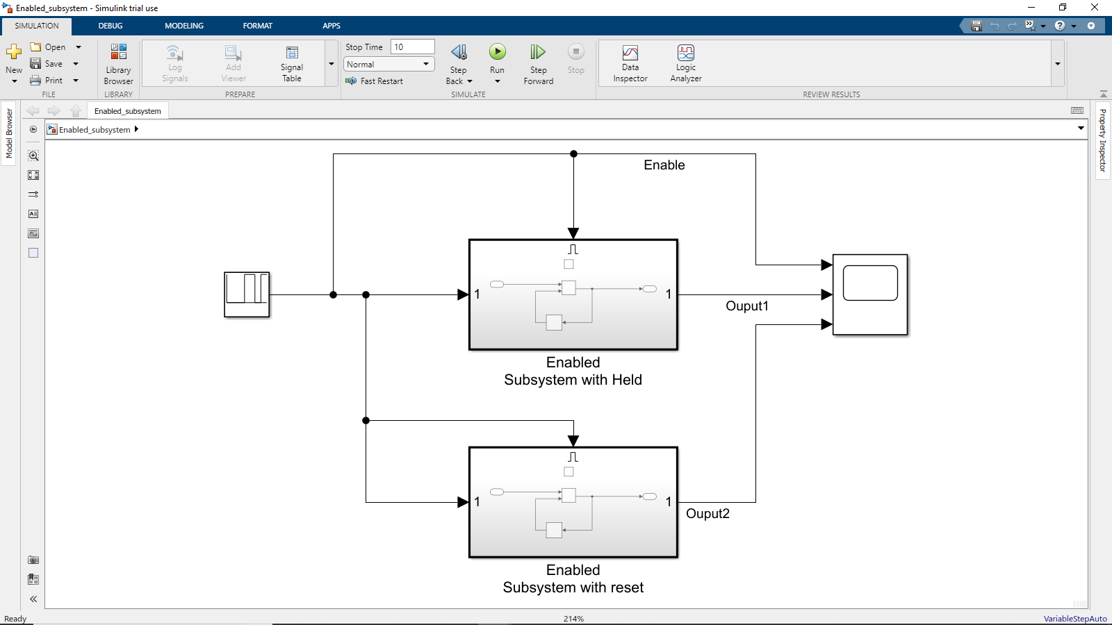

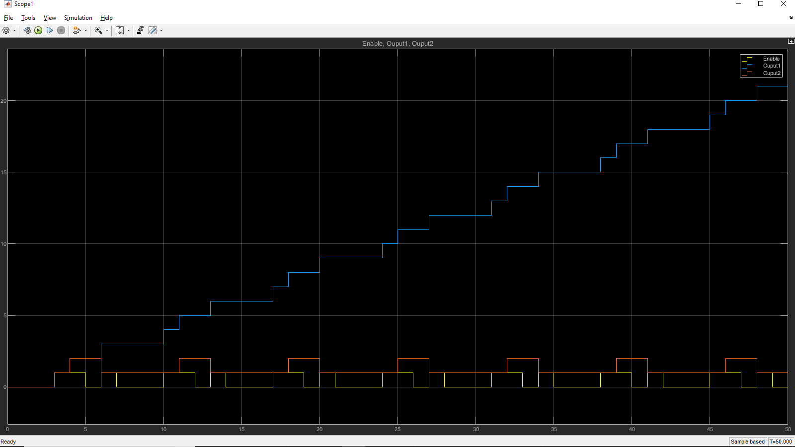

## Variant subsystem:

* Variant subsystems provides multiple implementations for a subsystem where only one implementation is active during simulation.
* A Variant Subsystem block contains two or more child subsystems where one child is active during model execution. The active child subsystem is referred to as the active variant. The active variant is programmatically wired to the Inport and Outport blocks of the Variant Subsystem by Simulink during model compilation.
* To programmatically control variant selection, a Simulink.Variant object is associated with each child subsystem in the Variant Subsystem block dialog. Simulink.Variant objects are created in the MATLAB base workspace. These objects have a property named Condition, which is an expression, that evaluates to a boolean value and is used to determine the active variant child subsystem. For example, defining

VSS_LINEAR_CONTROLLER=Simulink.Variant('VSS_MODE==1');

in the base workspace creates a Simulink.Variant object where the constructor argument ('VSS_MODE==1') defines when the variant is active. Using the Variant Subsystem dialog, you then associate VSS_LINEAR_CONTROLLER with one of the child subsystems within the Variant Subsystem. Defining

VSS_MODE=1

in the base workspace, activates the VSS_LINEAR_CONTROLLER variant. The condition argument can be a simple expression consisting of scalar variables, enumerations, equality, inequality, &&, , and ~. Parenthesis () can be used for precedence grouping.

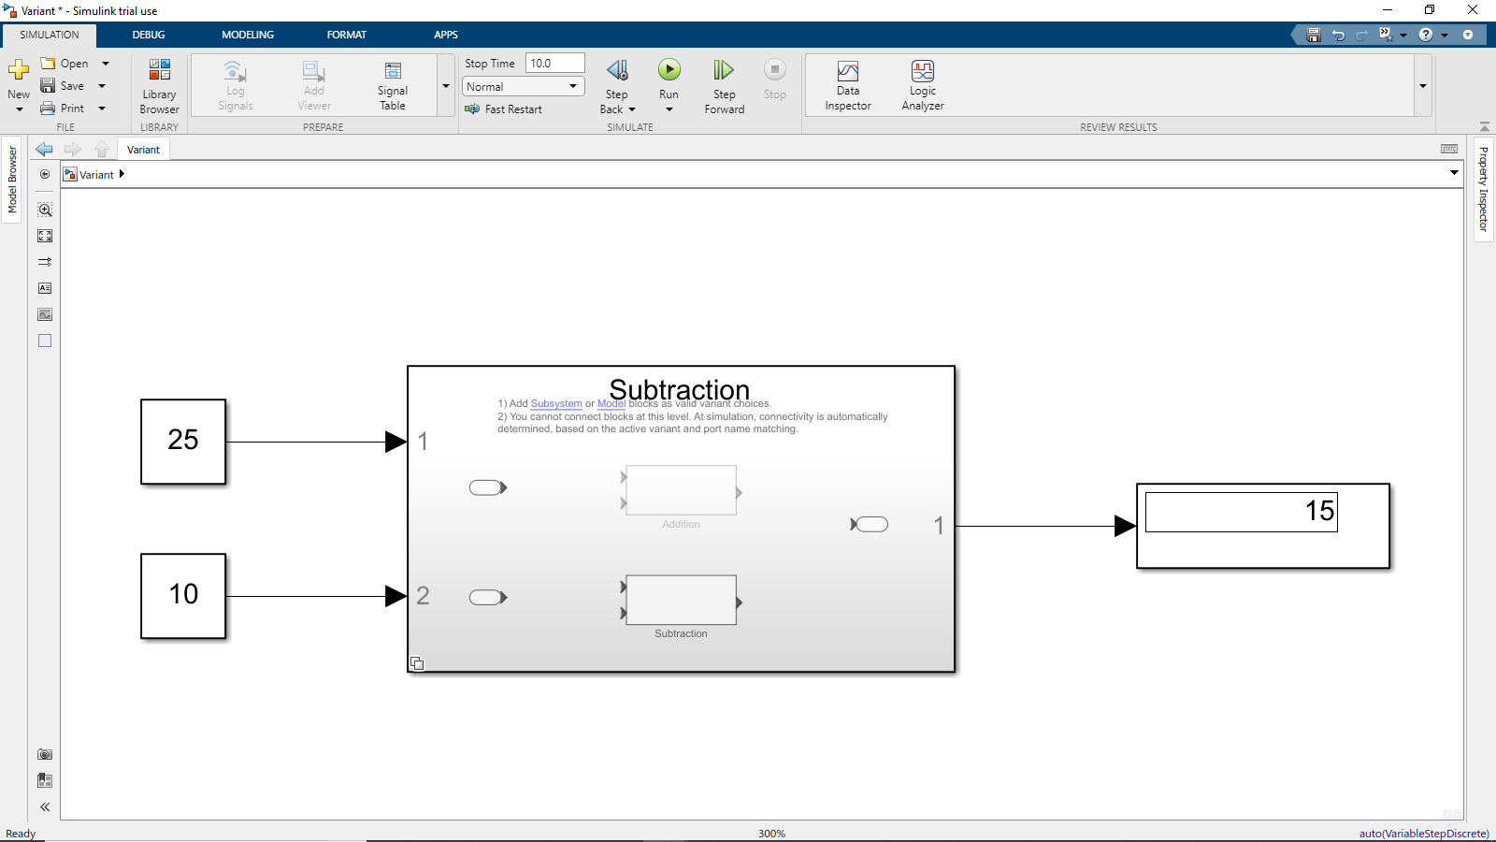

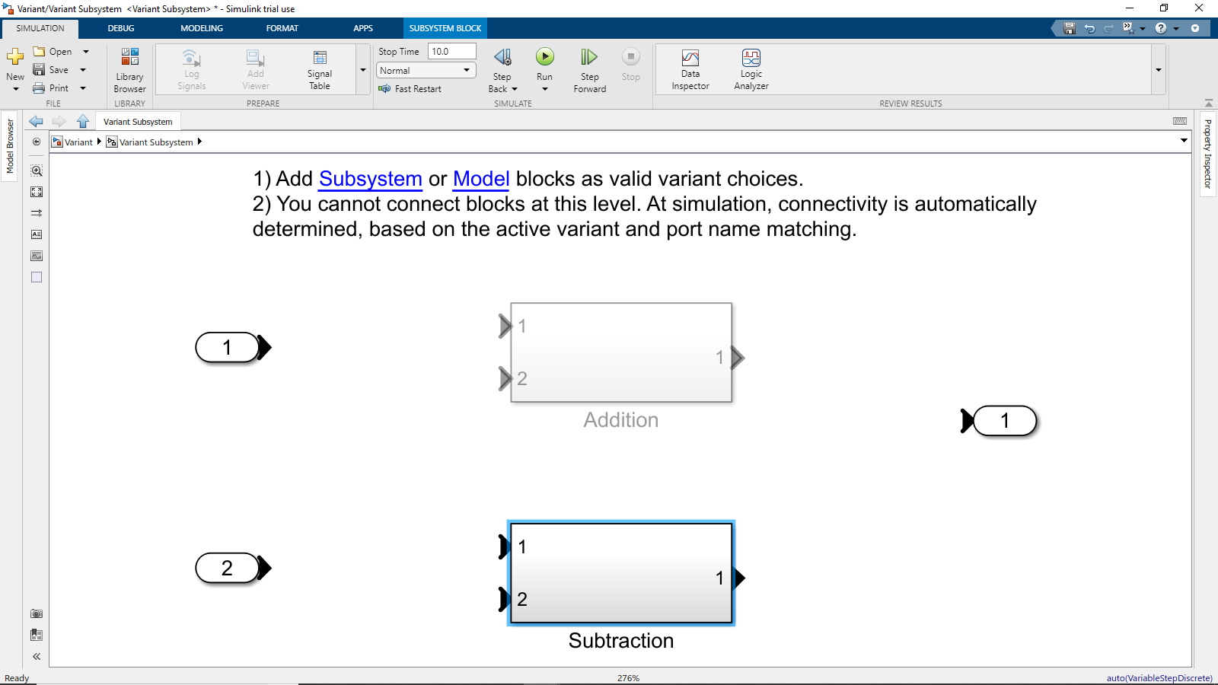

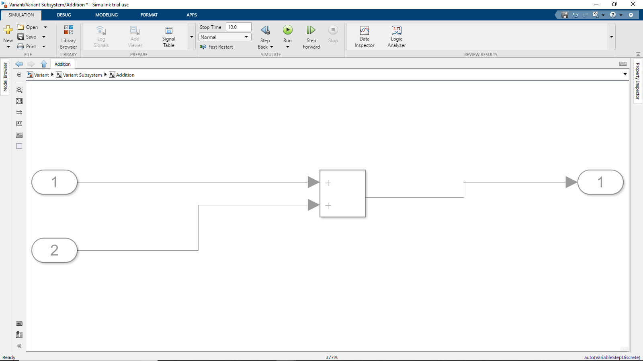

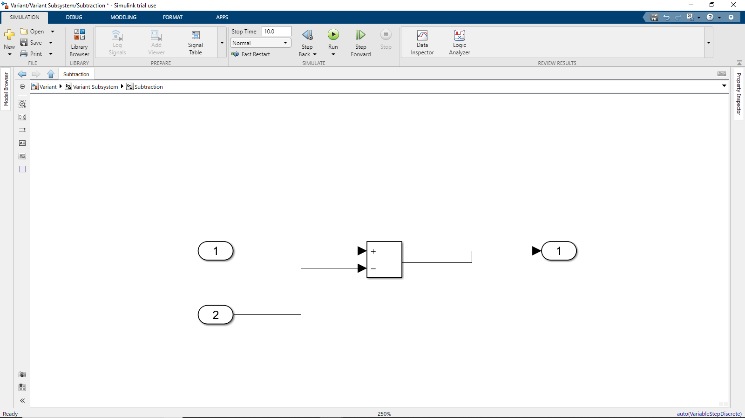

# Appendix

## MATLAB OnRamp course certificate



Figure 30 Matlab Onramp certificate

## Simulink Onramp course certificate



Figure 31 Simulink onramp certificate



Figure 32 Stateflow onramp certificate